Project 2 ANSYS DOE and Design Optimization

Chester Szatkowski

MAE 598 Design Optimization

11/17/2021

**Optimization Problem**

This project involves the optimization of a brake rotor for emergency braking conditions with the objectives of minimizing volume, minimizing stress, minimizing maximum temperature, and maximizing the first natural frequency. The Rotor’s outer diameter is constrained between 124mm and 160mm. The minimum is set by the geometry of the brake pad while the maximum is set to a feasible brake rotor size. The rotor inner diameter is constrained between 66mm and 90mm. The rotor thickness is constrained between 15mm and 25mm. The variables in the problem are rotor thickness, rotor outer diameter, and rotor inner diameter. These variables are all continuous as they can be any fractional value between the constraints. The most notable tradeoff is between volume and the other objectives. Decreasing volume has a significant negative impact on stress and temperature results of the rotor.

**Model Setup**

The model geometry was provided for the project. This was imported to Ansys and applied to a static structural, transient thermal, and modal analysis. Engineering data was selected for gray cast iron to be applied to the rotor and structural steel to the brake pads. Ansys “parameters” were shared between the analyses for the problem variables. The geometry, materials, and setup are shown below:

In the static structural model, the rotor is rotated along the y axis at 250 rad/s. A frictional contact is applied to the rotor and the inner surfaces of the pads. The brake pads are constrained in the x and z direction. Finally, a pressure of 10.5 MPA is applied to the outer surfaces of the pads. This setup is shown below:

In the transient thermal model, only the rotor is analyzed. Boundary conditions for convection are applied to all faces of the rotor at 5 W/m2. A heat flux of 1500 kW/m2 is applied to the surface of the rotor which contacts the pads (throughout the rotor rotation). This setup is shown below:

In the modal model, only the rotor is analyzed. The 7th mode of vibration is the only one of interest. This setup is shown below:

**Optimization**

The parameter set is connected to the Ansys response surface module. Design of experiments is set with the appropriate constraints for the three design variables. Latin Hypercube Sampling Design is chosen for design of experiments. 16 design points are created. This is then connected to an Ansys optimization module set to use the multiobjective genetic algorithm (MOGA) method with the objectives discussed above. This returns the following design points:

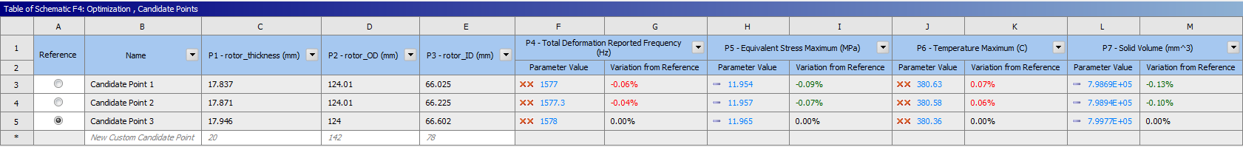

**Sensitivity**

Ansys plots the sensitivity of the variables as shown below:

This shows that rotor outer diameter has the largest effect on frequency with inner diameter and thickness having similar sensitivities. Maximum stress had a very low sensitivity for all variables. Maximum temperature was heavily dependent on rotor thickness. Volume was dependent most on outer diameter followed closely by thickness with inner diameter having a small impact.

**Optimized Design vs Original**

The optimized design has a thickness of 17.946 mm, an outer diameter of 124 mm, and an inner diameter of 66.602 mm compared to the original 25mm, 125mm, and 75mm respectively. The optimized design is shown below:

The original design had a volume of 996.67 mL, a maximum stress of 12.849 MPa, frequency of 1615.7 Hz, and a maximum temperature of 341.04°C. The new design returned 800.18 mL, 10.938 MPa, 1529.7, and 376.27°C respectively. The new design had a significantly reduced volume with slight increases to frequency and temperature.

The results of the original design are shown below:

The results of the optimized design are shown below:

